SHOPPE- E COMMERCE APP REDESIGN
NAME: S. NASREEN FARZANA
DEP: B.E.CSE
ROLL NUMBER: 511723104007

Figma link: https://www.figma.com/design/wnyW6sV7FfZO6mFJaBTaqy/SHOPPE?nodeid=0-1&t=5fXkI3jTQTNOFnZj-1

Prototype link: 👉FIgmaPrototype
Github link: https://github.com/Nasreen-17/E-commerce-app-redesign-.git

Step 1 – Research & User Understanding
Problem Statement:
Users abandon shopping carts due to confusing navigation, slow load times, and lengthy checkout steps.
Goal:
Redesign the e-commerce experience to make browsing, adding to cart, and checkout faster, simpler, and personalized.
Target Audience:
- College students and working professionals (18–35)
- Mobile-first shoppers who want convenience and reliability
User Persona:
Name: Aisha Patel, 27
Occupation: Marketing Executive
Goals: Quick checkout, easy comparison, trustworthy reviews
Pain Points: Confusing categories, poor filtering, too many checkout steps Empathy Map:
Thinks | Feels | Says | Does
“This site is confusing.” | Feels frustrated during checkout | “I’ll just order from  Amazon.” | Leaves cart halfway
Key Insights:
- Simplify checkout (reduce steps)
- Add personalized product suggestions
- Improve search and filters

Step 2 – Information Architecture & Wireframing
App Structure (Sitemap):
Home → Category → Product → Cart → Checkout → Order Confirmation
Low-Fidelity Wireframes:
Sketch or Figma gray-scale layouts for:
- Home Page
- Product Details
- Shopping Cart
- Checkout Page
- Order Confirmation
View my wierframe here: https://github.com/Nasreen-17/E-commerce-app-redesign-/blob/main/Wireframe-shoppe.png

Step 3 – Visual Design & Prototyping
Design Goals: Clean, trustworthy, easy to use.
Style Guide:
Color Palette:
- Primary Blue (#2A7FFF)
- Accent Yellow (#F7C948)
- Background: #FFFFFF
🖋 Typography:
- Font: Poppins (Regular, Medium, Bold)
- Headings: 24px, Body: 16px UI Components:
- Rounded product cards
- Minimal buttons (Add to Cart, Buy Now)
- Search bar with icon
High-Fidelity Screens:
- Home
- Product Details
- Cart
- Checkout
- Order Confirmation
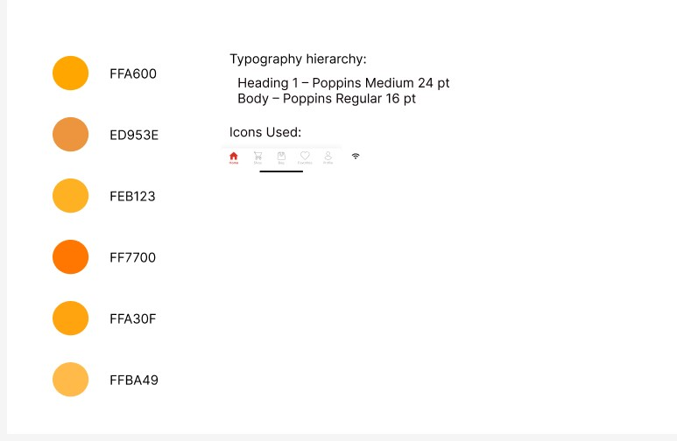
Prototype:
Link screens using Figma’s prototype mode.
Prototype link: 👉FIgmaPrototype

Step 4 – Usability & Interaction Design
User Flow Example:
Home → Select Product → Add to Cart → Checkout → Payment → Confirmation
Navigation Design:
Bottom navigation bar or tab menu with icons: Home | Cart | Profile
Key Interactions:
Feature Interaction Feedback
Product animation added to
Add to Cart Tap “+”
cart
Checkout Button click Progress indicator
Payment Tap Confirmation message
Accessibility:
- High color contrast
- Large, clear buttons
- Descriptive icons with text
View my README Here: https://github.com/Nasreen-17/E-commerce-app-redesign-/blob/main/README.pdf

Step 5 – Presentation & Documentation
Create a clean PowerPoint or PDF report with:
- Project Title (SHOPPE – E-Commerce App Redesign)
- Problem Statement
- Research & User Understanding
- Information Architecture
- Wireframes
- Visual Design
- Prototype Preview
- Usability & Interaction
- Learnings & Outcome

